**Practical 9**

**Develop an IoT module to which measure the intensity of light and send the same to your PC/ Phone**

**Steps to Perform:**

**Step 1:** 1) Take Breadboard

2) Take Resistor

3) Take LDR

4) Take Laptop

5) Take MCU Board

6) Take Jumping Cable

**Step 2:** 1) LDR put on Breadboard

2) Resistor going to connect one end of a resistor and one end of the Breadboard

3) We connect MCU Board to Breadboard Using Jumper wire

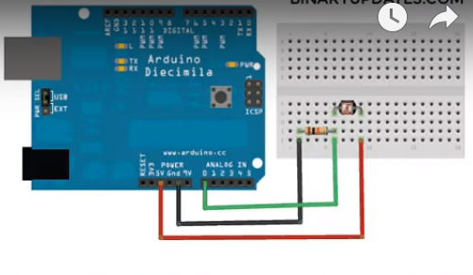

**Step 3:** 1) Now we will connect Breadboard and MCU board Using Red colour jumper wire

2) Then Connect MCU board to using Yellow colour jumper wire

3) Then free end of Resistor to MCU Board using Green Colour jumper wire

